NAAN MUDHALVAN ARTS INTERNSHIP PROGRAM 2026
PYTHON FOR DATA ANALYTICS
STUDENT NAME: AKALYA.J.L.V
YEAR: 2026
COLLEGE CODE: msu319
COLLEGE NAME: SREE DEVI KUMARI WOMENS COLLEGE
DEPARTMENT: B.SC.COMPUTER SCIENCE
SEMESTER: 4
ROLL NO: 24083191802112111
NMID: F2BE888DD5C4EBEBF0A46564DC214E56
TITLE: STUDENT PERFORMANCE & RESULT ANALYTICS
GITHUB LINK :
DATE: 23-06-2026

ABSTRACT

Project Overview
The Student Performance & Result Analytics project aims to analyze academic performance data of students and identify factors that influence their results. The dataset used for this project contains student information such as attendance, study hours, internal marks, assignment scores, and final examination results stored in a CSV file.
The main problem analyzed was understanding the relationship between various academic factors and student performance. Educational institutions often face challenges in identifying students who may require additional academic support. Through data analytics, hidden patterns and trends can be discovered to improve academic outcomes.

PROBLEM STATEMENT

Business Problem / Real-World Challenge
Educational institutions continuously monitor student performance to ensure academic success. However, analysing large volumes of student data manually is time-consuming and often ineffective. Many factors such as attendance, study habits, assignment completion, and internal assessment scores influence student performance.
Without proper analysis, institutions may fail to identify students who are at risk of poor performance. This can lead to lower pass percentages, decreased academic standards, and reduced student satisfaction.
Data analysis is needed to:
- Identify key factors affecting student results.
- Detect students who require academic support.
- Monitor performance trends over time.
- Improve decision-making in educational management.
- Enhance overall academic outcomes.
Expected improvements include better student performance tracking, early intervention for struggling students, improved resource allocation, and increased academic success rates.

OBJECTIVES
The project focuses on generating meaningful insights from datasets and improving understanding of data-driven decision-making processes.
Specific objectives include:
- Analyze student academic records.
- Identify factors affecting student performance.
- Compare performance across different student groups.
- Visualize trends and patterns using charts and graphs.
- Support educational decision-making through data insights.
- Improve understanding of data analytics techniques.

PROJECT SCOPE
This project focuses on analysing and visualizing data using Python in Google Collab to generate meaningful insights from datasets.
The scope includes:
- Loading student performance datasets.
- Data cleaning and preprocessing.
- Exploratory Data Analysis (EDA).
- Statistical analysis of academic performance.
- Data visualization and reporting.
- Generating actionable insights for educators and administrators.
The project is limited to analysing available historical student data and does not include predictive modelling or real-time monitoring systems.

TECHNOLOGIES USED
Development Environment
- Platform: Google Colab
- Programming Language: Python
Libraries Used
Pandas
- Used for data loading, cleaning, transformation, and manipulation.
NumPy
- Used for numerical operations and mathematical calculations.
Matplotlib
- Used for creating basic visualizations and charts.
Seaborn
- Used for advanced statistical visualizations and correlation analysis.
Dataset Source
- Dataset Type: CSV File
- Source: Student Academic Performance Dataset
- Data Includes:
  - Student ID
  - Attendance Percentage
  - Study Hours
  - Assignment Scores
  - Internal Marks
  - Final Exam Marks

APPLICATION FLOW

Step-by-Step Workflow
Step 1: Dataset Loading
The student performance dataset is uploaded and loaded into Google Colab using Pandas.
Step 2: Data Inspection
The dataset structure, column names, and data types are examined.
Step 3: Data Cleaning
- Missing values are identified and handled.
- Duplicate records are removed.
- Incorrect data formats are corrected.
Step 4: Data Preprocessing
- Data is organized and standardized.
- Relevant columns are selected for analysis.
Step 5: Exploratory Data Analysis (EDA)
- Summary statistics are generated.
- Performance trends are explored.
- Relationships between variables are examined.
Step 6: Visualization
Graphs and charts are created to represent:
- Score distributions
- Attendance trends
- Pass/Fail percentages
- Correlation between study hours and marks
Step 7: Insight Generation
Meaningful conclusions are derived from the analysis.
Step 8: Reporting
Results are summarized and documented for stakeholders.

KEY PYTHON DATA ANALYTICS CONCEPTS USED
- 1. Data Handling
- Reading CSV files using Pandas.
- Managing rows and columns.
- Data transformation and manipulation.
- 2. Data Cleaning
- Handling missing values.
- Removing duplicate records.
- Correcting inconsistent data.
- 3. Exploratory Data Analysis (EDA)
- Descriptive statistics.
- Correlation analysis.
- Pattern and trend identification.
- 4. Visualization
- Bar Charts
- Histograms
- Pie Charts
- Scatter Plots
- Heatmaps
- These visualizations help present analytical findings clearly and effectively.

EXPECTED OUTPUT
# Import libraries
import pandas as pd
import numpy as np
import matplotlib.pyplot as plt
import seaborn as sns

from sklearn.model_selection import train_test_split
from sklearn.linear_model import LinearRegression
from sklearn.metrics import mean_absolute_error, mean_squared_error, r2_score

# Display settings
sns.set_style("whitegrid")
df["Total_Marks"] = (
df["math score"] +
df["reading score"] +
df["writing score"]
)

df["Percentage"] = df["Total_Marks"] / 3

df.head()
def grade(p):
if p >= 90:
return "A"
elif p >= 80:
return "B"
elif p >= 70:
return "C"
elif p >= 60:
return "D"
elif p >= 50:
return "E"
else:
return "F"

df["Grade"] = df["Percentage"].apply(grade)

df.head()
subject_avg = [
df["math score"].mean(),
df["reading score"].mean(),
df["writing score"].mean()
]

subjects = ["Math", "Reading", "Writing"]

plt.figure(figsize=(7,5))
plt.bar(subjects, subject_avg)

plt.title("Average Subject Scores")
plt.ylabel("Average Marks")
plt.show()
plt.figure(figsize=(8,5))

sns.countplot(
x="Grade",
data=df,
order=["A","B","C","D","E","F"]
)

plt.title("Grade Distribution")
plt.show()
numeric_df = df[[
"math score",
"reading score",
"writing score",
"Percentage"
]]

plt.figure(figsize=(8,6))

sns.heatmap(
numeric_df.corr(),
annot=True,
cmap="coolwarm"
)

plt.title("Correlation Matrix")
plt.show()
plt.figure(figsize=(7,5))

sns.barplot(
x="lunch",
y="Percentage",
data=df
)

plt.title("Lunch Type vs Average Percentage")
plt.show()
plt.figure(figsize=(12,5))

sns.barplot(
x="parental level of education",
y="Percentage",
data=df
)

plt.xticks(rotation=45)
plt.title("Parental Education vs Student Performance")
plt.show()
X = df[[
"math score",
"reading score",
"writing score"
]]

y = df["Percentage"]
plt.figure(figsize=(7,5))

plt.scatter(y_test, y_pred)

plt.xlabel("Actual Percentage")
plt.ylabel("Predicted Percentage")
plt.title("Actual vs Predicted")

plt.show()
top_students = df.sort_values(
by="Percentage",
ascending=False
).head(10)

top_students[[
"math score",
"reading score",
"writing score",
"Percentage",
"Grade"
]]
print("Average Percentage :", round(df["Percentage"].mean(),2))
print("Highest Percentage :", round(df["Percentage"].max(),2))
print("Lowest Percentage :", round(df["Percentage"].min(),2))

print("\nGrade Distribution")
print(df["Grade"].value_counts())
OUTPUT
gender | race/ethnicity | parental level of education | lunch | test preparation course | math score | reading score | writing score
female | group B | bachelor's degree | standard | none | 72 | 72 | 74
female | group C | some college | standard | completed | 69 | 90 | 88
female | group B | master's degree | standard | none | 90 | 95 | 93
male | group A | associate's degree | free/reduced | none | 47 | 57 | 44
male | group C | some college | standard | none | 76 | 78 | 75
female | group B | associate's degree | standard | none | 71 | 83 | 78
female | group B | some college | standard | completed | 88 | 95 | 92
male | group B | some college | free/reduced | none | 40 | 43 | 39
male | group D | high school | free/reduced | completed | 64 | 64 | 67
female | group B | high school | free/reduced | none | 38 | 60 | 50
male | group C | associate's degree | standard | none | 58 | 54 | 52
male | group D | associate's degree | standard | none | 40 | 52 | 43
female | group B | high school | standard | none | 65 | 81 | 73
male | group A | some college | standard | completed | 78 | 72 | 70
female | group A | master's degree | standard | none | 50 | 53 | 58
female | group C | some high school | standard | none | 69 | 75 | 78
male | group C | high school | standard | none | 88 | 89 | 86
female | group B | some high school | free/reduced | none | 18 | 32 | 28
male | group C | master's degree | free/reduced | completed | 46 | 42 | 46
female | group C | associate's degree | free/reduced | none | 54 | 58 | 61
male | group D | high school | standard | none | 66 | 69 | 63
female | group B | some college | free/reduced | completed | 65 | 75 | 70
male | group D | some college | standard | none | 44 | 54 | 53
female | group C | some high school | standard | none | 69 | 73 | 73
male | group D | bachelor's degree | free/reduced | completed | 74 | 71 | 80
male | group A | master's degree | free/reduced | none | 73 | 74 | 72
male | group B | some college | standard | none | 69 | 54 | 55
female | group C | bachelor's degree | standard | none | 67 | 69 | 75
male | group C | high school | standard | none | 70 | 70 | 65
female | group D | master's degree | standard | none | 62 | 70 | 75
female | group D | some college | standard | none | 69 | 74 | 74
female | group B | some college | standard | none | 63 | 65 | 61
female | group E | master's degree | free/reduced | none | 56 | 72 | 65
male | group D | some college | standard | none | 40 | 42 | 38
male | group E | some college | standard | none | 97 | 87 | 82
male | group E | associate's degree | standard | completed | 81 | 81 | 79
female | group D | associate's degree | standard | none | 74 | 81 | 83
female | group D | some high school | free/reduced | none | 50 | 64 | 59
female | group D | associate's degree | free/reduced | completed | 75 | 90 | 88
male | group B | associate's degree | free/reduced | none | 57 | 56 | 57
male | group C | associate's degree | free/reduced | none | 55 | 61 | 54
female | group C | associate's degree | standard | none | 58 | 73 | 68
female | group B | associate's degree | standard | none | 53 | 58 | 65
male | group B | some college | free/reduced | completed | 59 | 65 | 66
female | group E | associate's degree | free/reduced | none | 50 | 56 | 54
male | group B | associate's degree | standard | none | 65 | 54 | 57
female | group A | associate's degree | standard | completed | 55 | 65 | 62
female | group C | high school | standard | none | 66 | 71 | 76
female | group D | associate's degree | free/reduced | completed | 57 | 74 | 76
male | group C | high school | standard | completed | 82 | 84 | 82
male | group E | some college | standard | none | 53 | 55 | 48
male | group E | associate's degree | free/reduced | completed | 77 | 69 | 68
male | group C | some college | standard | none | 53 | 44 | 42
male | group D | high school | standard | none | 88 | 78 | 75
female | group C | some high school | free/reduced | completed | 71 | 84 | 87
female | group C | high school | free/reduced | none | 33 | 41 | 43
female | group E | associate's degree | standard | completed | 82 | 85 | 86
male | group D | associate's degree | standard | none | 52 | 55 | 49
male | group D | some college | standard | completed | 58 | 59 | 58
female | group C | some high school | free/reduced | none | 0 | 17 | 10
male | group E | bachelor's degree | free/reduced | completed | 79 | 74 | 72
male | group A | some high school | free/reduced | none | 39 | 39 | 34
male | group A | associate's degree | free/reduced | none | 62 | 61 | 55
female | group C | associate's degree | standard | none | 69 | 80 | 71
female | group D | some high school | standard | none | 59 | 58 | 59
male | group B | some high school | standard | none | 67 | 64 | 61
male | group D | some high school | free/reduced | none | 45 | 37 | 37
female | group C | some college | standard | none | 60 | 72 | 74
male | group B | associate's degree | free/reduced | none | 61 | 58 | 56
female | group C | associate's degree | standard | none | 39 | 64 | 57
female | group D | some college | free/reduced | completed | 58 | 63 | 73
male | group D | some college | standard | completed | 63 | 55 | 63
female | group A | associate's degree | free/reduced | none | 41 | 51 | 48
male | group C | some high school | free/reduced | none | 61 | 57 | 56
male | group C | some high school | standard | none | 49 | 49 | 41
male | group B | associate's degree | free/reduced | none | 44 | 41 | 38
male | group E | some high school | standard | none | 30 | 26 | 22
male | group A | bachelor's degree | standard | completed | 80 | 78 | 81
female | group D | some high school | standard | completed | 61 | 74 | 72
female | group E | master's degree | standard | none | 62 | 68 | 68
female | group B | associate's degree | standard | none | 47 | 49 | 50
male | group B | high school | free/reduced | none | 49 | 45 | 45
male | group A | some college | free/reduced | completed | 50 | 47 | 54
male | group E | associate's degree | standard | none | 72 | 64 | 63
male | group D | high school | free/reduced | none | 42 | 39 | 34
female | group C | some college | standard | none | 73 | 80 | 82
female | group C | some college | free/reduced | none | 76 | 83 | 88
female | group D | associate's degree | standard | none | 71 | 71 | 74
female | group A | some college | standard | none | 58 | 70 | 67
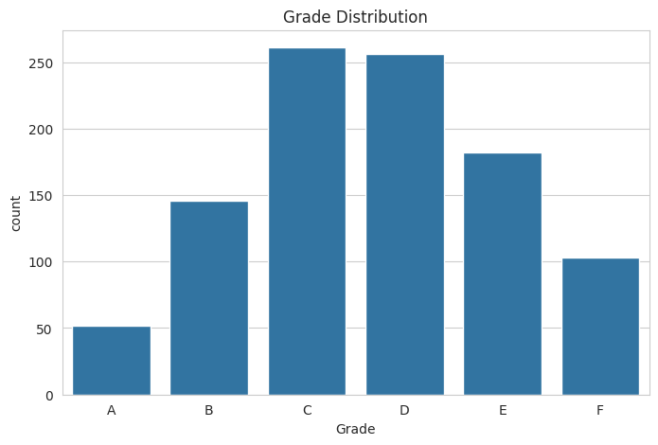
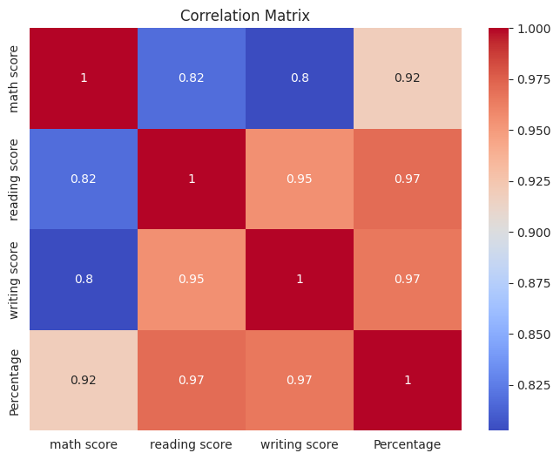
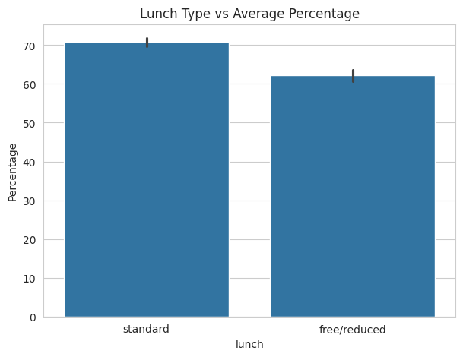
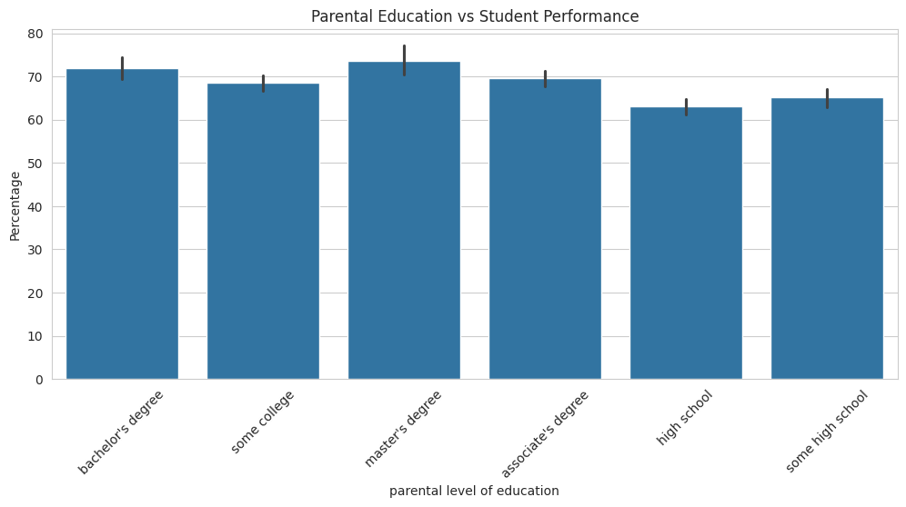

CHALLENGES FACED

Difficulties Encountered
Missing Data
Some records contained missing values.
Solution:
Missing values were handled using appropriate replacement techniques or row removal.
Data Inconsistency
Certain columns contained inconsistent formatting.
Solution:
Data preprocessing techniques were applied to standardize values.
Visualization Selection
Choosing suitable charts for representing educational data was challenging.
Solution:
Different visualization techniques were tested to select the most informative representations.
Understanding Relationships
Identifying significant factors affecting performance required extensive analysis.
Solution:
Correlation analysis and comparative visualizations were performed.

LEARNING OUTCOMES

Skills Gained
Technical Learning
- Python programming fundamentals.
- Data manipulation using Pandas.
- Numerical analysis using NumPy.
- Data visualization using Matplotlib and Seaborn.
- Exploratory Data Analysis techniques.
- Data preprocessing and cleaning methods.
Practical Experience
- Working with real-world datasets.
- Extracting meaningful insights from data.
- Presenting analytical findings through visualizations.
- Applying data-driven decision-making approaches.
- Developing problem-solving skills using analytics.

CONCLUSION
The Student Performance & Result Analytics project successfully analyzed student academic data and generated meaningful insights regarding factors affecting performance. Through data cleaning, exploratory data analysis, and visualization techniques, important relationships between attendance, study habits, and examination results were identified.
The project demonstrated how data analytics can assist educational institutions in monitoring student progress and making informed decisions. By identifying trends and performance patterns, educators can implement targeted interventions to support students and improve academic outcomes.
Overall, the project achieved its objectives by transforming raw student data into valuable information that supports better educational planning and performance management. The implementation highlights the importance of data-driven approaches in modern academic environments and provides a foundation for future predictive analytics projects.

